**Style Guide**

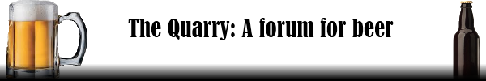**The banner:**

Specifications:

Width: 600px

Height: 100px

**CSS Website Specifications**:

Body background: #ccc (gray)

**Navigation bar:**

Width: 600px

Background: Black

Navigation Unordered List (ul): display: inline

**Navigation links:**

On hover: color is #D2691E (Orange)

Lettering: color white

**Footer:**

Color: dark gray

Lettering color: black

Text align: right

**Top Beer Page**

Unordered List (ul): default settings